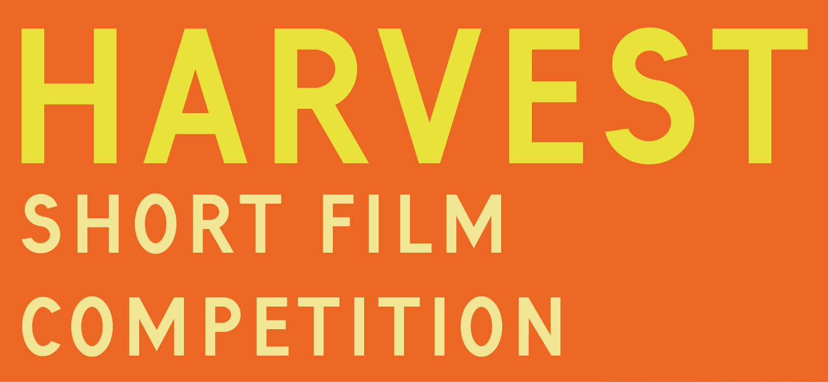

Please fill in this submissions form and return it as a word document or PDF to
harvest@lowerhewoodfarm.org no later than midnight Friday 4th August 2017.

Information about you:

Name
Address

Phone
Email

Biography
(200 words max.)

Links to website or any other relevant online material:

Information about your film:

Title:
Duration (max. 15 mins):
Year produced:
Director:
Producer:
Editor:
Music:
Other credits:

Please note that in order for us to screen your film, all rights must be your own or in place.

Synopsis
(200 words)

Viewing your film

Link to your film online (preferred):
or
Date you posted your film:
(DVD or flashdrive)
Address to send your film is:
Harvest Film Festival Submissions, Lower Hewood Farm, Hewood, Chard, Dorset. TA20 4NR

